In this phase, the timer and deathCount function was added. The program was modified to the items and map can scale. This was built to overcome problems with the maze being too large for the screen.

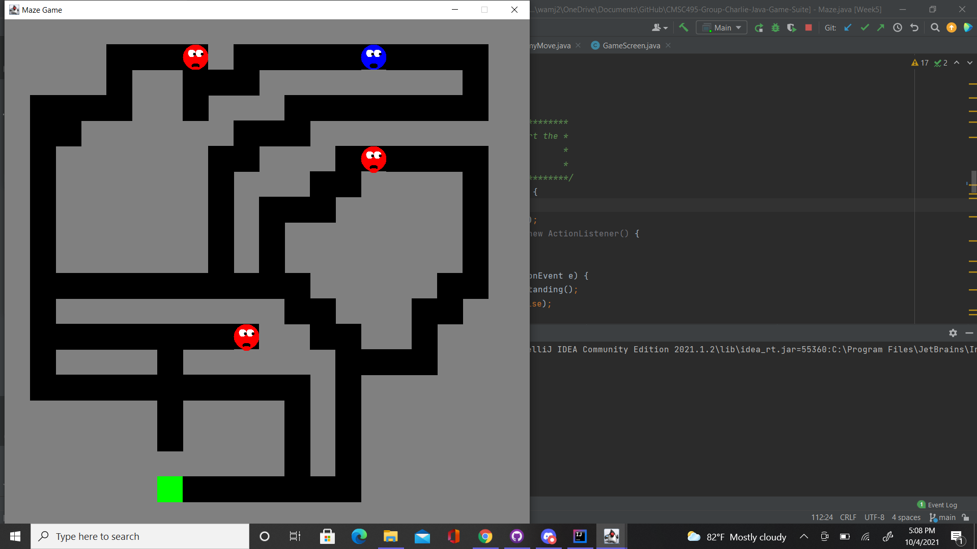

Figure 1: Example of Scaling the maze for larger fields.

With the introduction of timekeeping, two threads are now being used; one for the enemy movement and the other for the time lapsing. This has initially caused exceptions to be thrown where either functionality would stop. The threads for both were modified and the program runs with out errors.The high score will now show up on the opening screen rather than as its own menu.

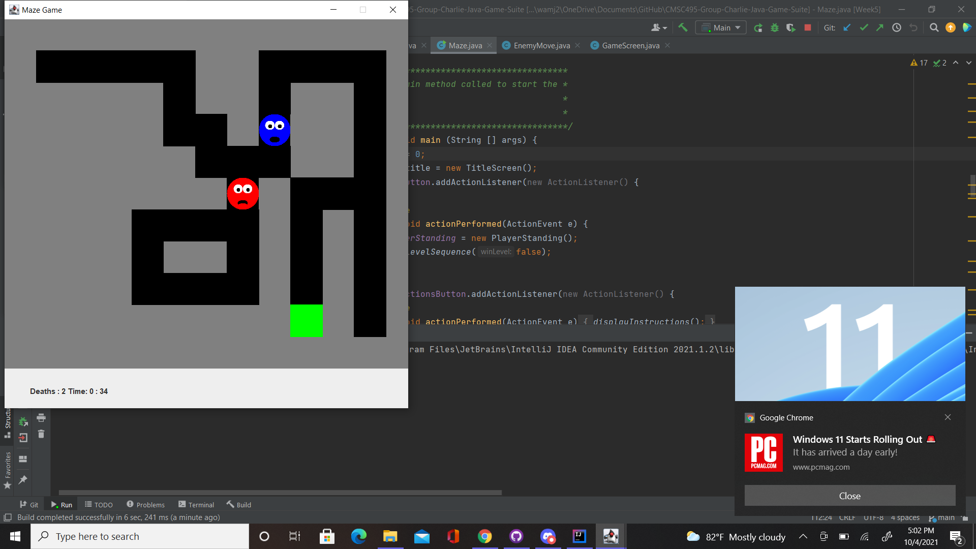

Figure 2: Challenge where you have to lure the enemy to get around it.

Some level modifications have also been added to make going to the exit the main challenge. For this reason, the enemy placement now plays a role in the difficulty of the maze.

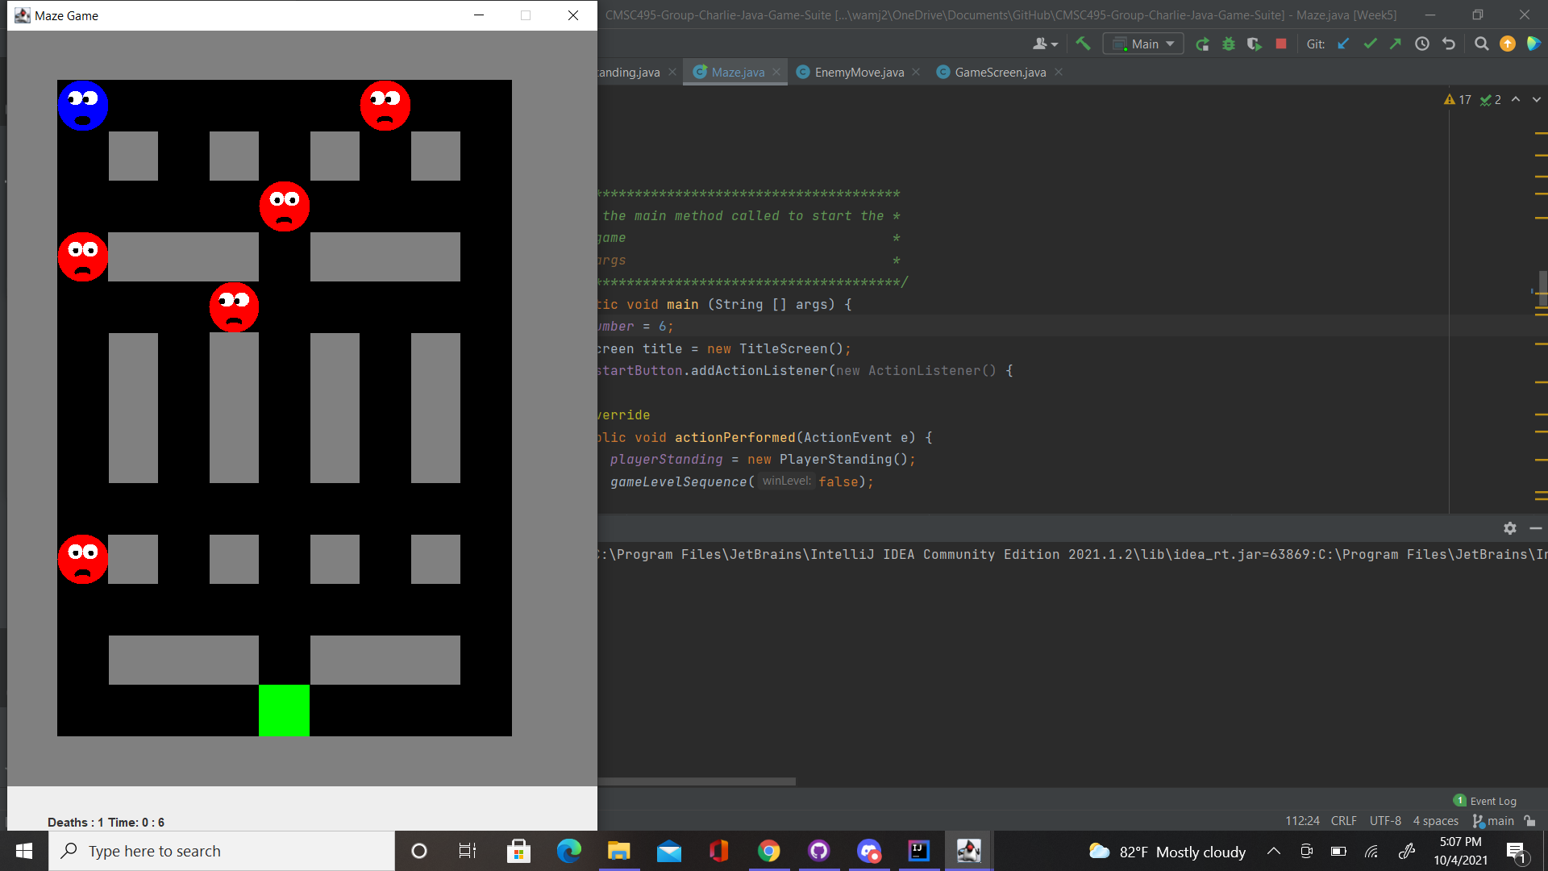

Figure 3: Challenge involving multiple enemies.